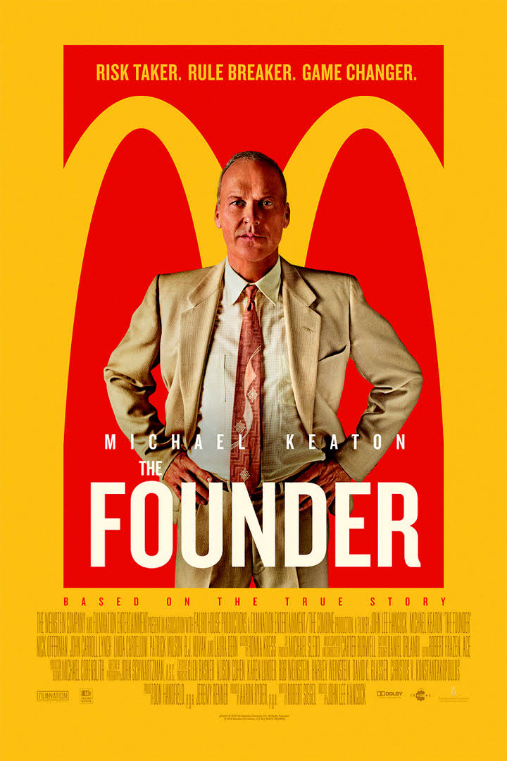

Consumer Studies 1202 /25
The Founder Assignment Name: _________________________________________

- What does Ray Kroc sell to restaurants at the beginning of the movie? (1)
________________________________________________________________________

- How many milkshake machines does McDonald's order from Ray Kroc? (1)
________________________________________________________________________

- When Ray Kroc went to McDonald’s for the first time, how much did his hamburger, french fries and drink cost? (1)
________________________________________________________________________

- What was the purpose of drawing out the new design of the kitchen on the tennis courts? (2)
________________________________________________________________________________________________________________________________________________________________________________________________________________________

- What did Ray Kroc suggest to the McDonald’s brothers to grow their business? (1)
________________________________________________________________________________________________________________________________________________

- Why did the McDonald’s brothers not want to franchise their business? (2)
________________________________________________________________________________________________________________________________________________

- Why does Ray Kroc want to renegotiate his contract with the McDonald’s brothers? (2)
________________________________________________________________________________________________________________________________________________

- What does Joan suggest as an idea to lower the cost of the electric bill for the freezers? (2)
________________________________________________________________________________________________________________________________________________
________________________________________________________________________________________________________________________________________________

- What does Harry Sonneborn suggest Ray Kroc do to change his business model? (2)
________________________________________________________________________________________________________________________________________________

- Finish the statement: (1)
Contracts are like hearts,
______________________________________________________________________.

- According to Ray Kroc, what is the one thing that makes McDonald’s special? (1)
_______________________________________________________________________

- Where does Ray Kroc open the new McDonald’s location in San Bernardino? (1)
_______________________________________________________________________

Reflection: Do you think the McDonald’s brothers did the right thing by selling out to Ray Kroc? Did Ray Kroc give the brothers a good deal? Does this change your view of McDonalds? What are you overall thoughts about the movie? Write your reflection - you need at least 2 paragraphs (8 marks)
_______________________________________________________________________________________________________________________________________________________________________________________________________________________________________
_______________________________________________________________________________________________________________________________________________________________________________________________________________________________________________________________________________________________________________________________________________________________________________________________________________________________________________________________________________________________________________________________________________________________________________________________________________________________________________________________________________________________________________________________________________________________________________________________________________________________________________________________________________________________________________________________________________________________________________________________________________________________________________________________________________________________________________________________________________________________________________________________________________________________________________________________________________________________________________________________________________________________________________________________________________________________________________________________________________________________________________________________________________________________________________________________________________________________________________________________________________________________________________________________________________________________________________________________________________________________________________________________________________________________________________________________________________________________________________________________________________________________________________________________________________________________________________________________________________________________________________________________________________________________________________________________________________________________________________________________________________________________________________________________________________________________________________________________________________________________________________________________________________________________________________________________________________________________________________________________________________________________________________________________________________________________________________________________________________________________________________________________________________________________________________________________________________________________________________________________________________________________________________________________________________________________________________________________________________________________________________________________________________________________________________________________________________________________________________________________________________________________________________________________________________________________________________

